The Optimist CLub of Frederick

FREDERICK, MD – The Optimist Club of Frederick recently donated new ‘Find It’ games to the Frederick Health Pediatric Unit. These popular hidden object search games will help keep young patients entertained during their hospital stay.
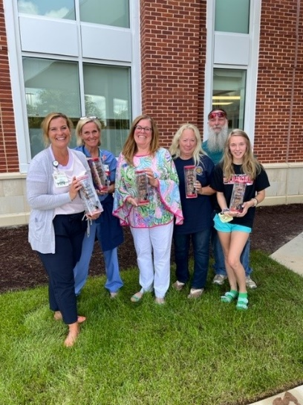

Presenting the donation to nurses from the Pediatric Unit are Optimist Club members Dianne Shelton, Julie Zebroski, Tommy Zebroski, and Junior Optimist Club member Makenzie Zebroski.

The Optimist Club of Frederick is dedicated to “Bringing Out the Best in Kids’ and does their part through community service projects. For more information on The Optimist Club of Frederick visit https://www.facebook.com/The-Optimist-Club-of-Frederick-166939056779701/

###

